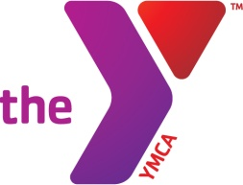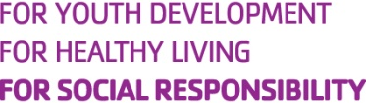

GRAND FORKS YMCA FAMILY CENTER
Scholarship Information and Application

Financial Assistance Policy
The YMCA Family Center is a non-profit community service organization serving Grand Forks, East Grand Forks and the surrounding communities. Our mission is to promote Christian principles through programs that build healthy spirit, mind and body for all. The YMCA staff and volunteer leadership stand behind its mission to provide membership, programs and services to everyone in the community, regardless of their financial circumstances. Through the generous donations of individuals and businesses, foundations and the support of the YMCA Partner of Youth Scholarship Program and the United Way, we are able to provide scholarship assistance to make that possible. Scholarships are provided within the limits of available funding.

Level of Assistance
The level of assistance available to individuals and families is based upon a sliding fee scale that takes into consideration your gross household income and number of dependents. The YMCA believes in establishing a sense of ownership and pride in one’s involvement in the YMCA. Therefore, applicants will always be asked to pay a portion of the membership, program or service fees. This fee must be paid prior to participation as a member or program services.
For our participants with a disability, if your participation requires the assistance of an escort, there will be no charge for the escort.

Eligibility Requirements
Since a limited amount of funds are available, priority will be given to those participants with the greatest need. The program is designed to aid those in a “crisis” or “high-risk” situation. Examples of such situations include: a disability, medical referral, rehabilitation, single-parent household or special family arrangements and extremely low income.
The YMCA realizes that individuals and families may sometimes experience unexpected, temporary situations or hardships that affect one’s ability to pay. If your tax return or pay stub does not truly indicate your hardship, please include a letter stating your particular hardship.

How to Apply
Applicants must complete the attached application in full. We require that all applicants submit verification of their income with their completed application. Income verification must be current and includes: pay check stubs, unemployment check stubs, disability or social security statements, government and/or other assistance verification. All information provided during the application process will remain confidential.

YMCA FAMILY CENTER
PROGRAM SCHOLARSHIP APPLICATION

Date of Application:____________ Month of Income Verification:_______________

Name:_________________________________________________

Address:_______________________________________________

Phone: (Home)_______________(Work)_______________(Cell)_________________

E-Mail:_______________________________SSN:_____________________

Members of your immediate family and birth date:
___________________________________DOB_________
___________________________________DOB_________
___________________________________DOB_________
___________________________________DOB_________

How would a program scholarship help or benefit your family? __________________________________________________________________________________________________________________________________________________________________________________________________________________________________________

Program request:______________________________________________________________

PLEASE NOTE: The following financial information requested below will remain confidential and is necessary for approval of scholarship assistance.

Program Fee YMCA Scholarship Request Applicant Responsibility

____________ = _________________________ + _____________________

Family Monthly Income:* Other Sources of Support:

_____$0 - $12,000 _____Alimony $_______per month
_____$12,001 - $20,000 _____Child Support $_______per month
_____$20,001 - $30,000 _____Social Security $______ per month
_____$30,001 - $40,000 _____AFDC $_______per month
_____$40,001 - $50,000 _____Assistance $_______per month
_____Other $_______per month
****SEE REVERSE SIDE TO COMPLETE APPLICATION****
*Please attach supporting documentation to verify your income by attaching your most recent personal tax return or payroll information.

Have you previously applied for YMCA scholarship assistance? ____Yes ____No

Agency/person who referred you to the Y Scholarship Program?_______________________

Scholarship Assistance Policy

Within the limits of available funding, the YMCA does not refuse membership or
program services to any person due to their proven inability to pay the cost of
participation. Scholarship Assistance is available through funding provided by the
YMCA Partner of Youth Program and the United Way.
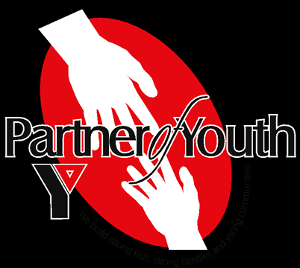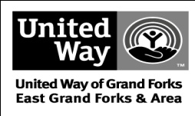

SCHOLARSHIP INFORMATION SHEET
What is a Scholarship for membership or programs? The scholarships are available through funding provided from individuals and businesses to the GF YMCA Partner of Youth Scholarship Program, foundation support and the United Way, which is designated to assist individuals and families in a financial crisis to pay for memberships or program fees.

Who qualifies for a Scholarship? The scholarship program has been developed for individuals or families in what would be considered a crisis situation. A “crisis situation” would include: a disability, medical referral, rehabilitation, a family situation or any other situation where assistance is needed, and there is no other alternative available to them.

How do I get a Scholarship? The first step to acquiring assistance is to complete a scholarship application form, which is available at the YMCA Customer Service Desk or on the website at www.gfymca.org. Once completed, the application is returned to the YMCA, and the Associate Executive Director will contact you for an appointment.

Do I need to bring anything to the appointment? Yes, you will need to bring a form of income verification. This verification would include current pay stubs, copies of any assistance or child support you may be receiving, or your most recent tax return. Income verification is required at least once a year.

What happens at this appointment? During your appointment, we will discuss what is included in the membership or what program options are available, you will be offered a tour, and we will discuss your assistance need and determine an appropriate fee.

Who do I contact if I have questions?
Please contact Bob McWilliams, Associate Executive Director, at the GF YMCA Family Center, 775-2586.
------------------------------------------------------------------------------------------------------------
FOR OFFICE USE ONLY

Approved:__________ Denied:__________ Incomplete Application:__________
Program Requested:_______________________________________________________ Program Rate: $__________ Scholarship Amount $ ___________
Recommended by:_____________________________Expiration Date:______________

