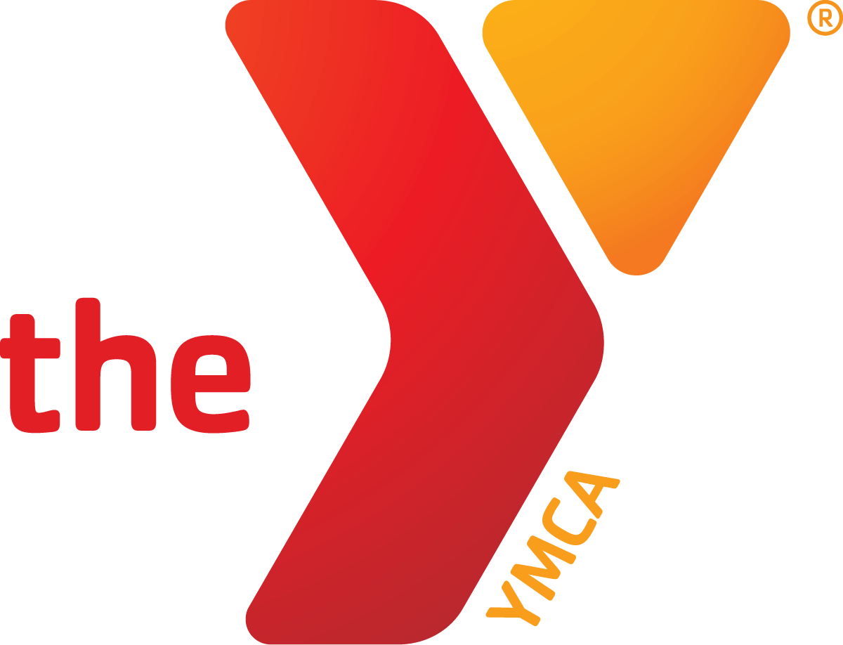

APPLICATION FOR EMPLOYMENT
(Please print clearly in ink)

Applicants are considered for all positions without regard to race, color, religion, sex, national origin, age, marital or veteran status, or the presence of a physical or mental handicap or disability, or any other characteristic protected by law. It is our intention that all applicants be given equal opportunity and that selection decisions are based on job-related factors.

Date of Application__________Date Available__________Position Applying for_____________________

Name: Last______________________First_____________Middle Initial_____Phone No. (___)_________

Address_________________________________City_____________________State_______Zip________

Would you accept: Full Time Part Time for________hours/week Weekend Work______

Temporary Summer Only

Hours/Days Available to Work __________________________________________________________

Area of Interest for Work: _______Aerobics _______Aquatics_______Child Care________Customer Service
_______Custodial________Day Camp _______Fitness Center________Youth
Other: _________________
Position Applying to Work:__________________________________
Are you over 16 years of age? _____Yes _____No

Have you ever been convicted of a felony? _____Yes _____No
A criminal conviction does not by itself constitute an absolute bar to employment. The YMCA Family Center will examine the nature of the conviction record, subsequent rehabilitation, and the responsibilities of the position sought in making each employment decision.

EDUCATION DATA

Circle Highest Grade Completed: 6 7 8 9 10 11 12 College: 1 2 3 4 5 6 7 8
Name of Last School Attended_______________________City/State______________________
Attended From: Month_________Year_______ To: Month__________Year_______ Graduated?_______
Diploma_____________ Degree (type)____________________Major Area of Study__________________
Other Education Relevant to Position________________________________________________________

Professionals: ND License or Certificates____________________________________________________
Clerical Applicants: Check equipment you have experience in operating:
____Calculator Typing Speed_____wpm _____Copy/Fax Machines _____Cash Registers
____Computer Please List Software: Programs_____________________________________________
Other Training: (Courses, Workshops, or Other Qualifications Applicable to this Position)
__________________________________________________________________________________________________________________________________________________________________________________________________________________________________________________________________________________________________________________

PLEASE COMPLETE BOTH SIDES OF APPLICATION

PRESENT OR MOST RECENT EMPLOYMENT INFORMATION

1. Firm__________________________________________________Phone No. (____)_______________
Address___________________________________City_______________State_______Zip_________
Name of Immediate Supervisor and Their Title______________________________________________
Position Held__________________________Dates of Employment_____________________________
Duties______________________________________________________________________________
Reason for Leaving____________________________________________________________________
May We Contact the Employer Listed Above as a Reference?_______________________________

PREVIOUS EXPERIENCE OR PERSONAL REFERENCE

2. Name of Reference______________________________________Phone No. (____)_______________
Address___________________________________City_______________State_______Zip_________
If Previous Employer:
Position Held__________________________Dates of Employment_____________________________
Duties______________________________________________________________________________
Reason for Leaving____________________________________________________________________

PERSONAL REFERENCE

3. Name of Reference______________________________________Phone No. (____)_______________
Address___________________________________City_______________State_______Zip_________
Relationship to Reference Person______________________________

“I hereby authorize all of my former employers, school officials, and other persons with whom I have been professionally associated with as reference to give to the YMCA Family Center any information that they may have regarding my employment record, together with any information they may have regarding me, whether or not such information is on their records. I hereby release said companies and individuals from any liability for any damages whatsoever resulting from the giving of such information.”

Dated:____________________________Signature:__________________________________________

CERTIFICATION OF UNDERSTANDING

I Certify that all matters contained in this application are true, authorize their investigation and agree that any misleading or false statements would render this application void and is sufficient cause for immediate dismissal in the event of employment.
I understand that my employment is dependent upon receipt by the YMCA of satisfactory references, attendance at orientation, verification of certification in CPR, and completion of the probationary period.
I agree to conform to the rules and regulations of the Altru Family YMCA and acknowledge that these rules and regulations may be changed, interpreted, withdrawn, or added to, by the Altru Family YMCA at any time and without prior notice to me. I understand that nothing contained in this employment application or in the granting of an interview is intended to create an employment contract between the YMCA and myself for either employment or for the providing of any benefits. No promises regarding employment have been made to me, and I understand that no such promise or guarantee is binding unless expressly made in writing. If an employment relationship is established, I understand that I have the right to terminate my employment at any time, and the YMCA retains a similar right regarding the discontinuation of my employment.

Dated:______________________________Signature:_________________________________________

YMCA Mission:
To put Christian principles into practice through programs that build healthy spirit, mind and body for all.

